The main goal of randomized trial Project 0 is to explore the relationship between a new dental gel treatment and dental health as indicated by two dental measurements taken at baseline and repeated at one year of follow-up. These measurements include whole mouth average attachment loss (cm) and whole mouth average pocket depth (cm). This study uses different concentrations of the treatment dental gel and aims to investigate if the different gel concentrations are associated with decreased values of whole mouth average attachment loss and whole mouth average pocket depth. These differences in gel concentration included a no treatment control group, a placebo control group (a gel with no concentration of treatment), a low concentration of treatment, a medium concentration of treatment, and a high concentration of treatment. Participants, who were recruited from one Midwestern clinic, were instructed to apply the gel to their gums twice daily. Data received included information on the measurements of whole mouth average pocket depth and whole mouth average attachment loss, treatment assignment, race, gender, sex, smoking status, and the number of sites used to compute the whole mouth averages. Some data were missing including some one year follow up dental measurements and some demographic measurements. From this dataset and consultation with the investigators, an analysis plan was made.

The main software used in the analysis of Project 0 was SAS 3.6 Enterprise Edition. Data were first read in and then cleaned. The missing values were entered as “NA” in the .csv file for the variables whole mouth average attachment loss at one year of follow up(attach1year) and whole mouth average pocket depth at one year of follow up(pd1year). SAS imported these variables as characters and steps were taken to remove the “NA”s and change the variable type to numeric for use in further analysis as part of the data cleaning process. Dental measure change variables were then created to signify the difference in measurements from baseline to one year of follow up. This was done for both attachment loss and pocket depth variables by subtracting the baseline values from the one year follow-up values. These difference variables were then set to be the dependent variables.

After the outcome variables were created, data was recoded to dummy code. All variables were recoded so that the lowest value was 0. A summary of the variables and dummy code can be found in Table 1.

**Table 1. Summary of Dummy Coded Variables**

|  |  |  |  |  |
| --- | --- | --- | --- | --- |
| Code | Treatment | Sex | Race | Smoker |
| 0 | No treatment | Male | Native American | No |
| 1 | Placebo (blank gel) | Female | African American | Yes |
| 2 | Low concentration |  | Asian |  |
| 3 | Medium concentration |  | White |  |
| 4 | High concentration |  |  |  |

Once the variables were created, summary statistics were viewed. Results from continuous the summary statistics are included in Table 2. There were 27 participants missing at year one on follow-up, and a missing age value. For continuous variables, the PROC MEANS statement was used to determine n, mean, variance, standard deviation, number of missing values, minimum, and maximum. For categorical variables, the PROC FREQ statement was used to determine the frequency and percentage of each value.

Two models were run regressing treatment group against attachment loss difference and pocket depth difference. From these models, assumptions for linear regression were assessed and met. Crude linear regression models were then run using the PROC REG statement. For the remainder of the analysis, two regressions were run: one for difference in attachment loss values and one for difference in pocket depth values. The crude regression models included the dependent variable attachment difference and pocket depth difference and the different treatment groups (placebo (blank gel), low, medium, and high) with the no treatment control group as a reference. These models were viewed and a PROC CORR statement was then used to assess any potential correlations between variables. From this analysis, it was decided the baseline values of attachment and pocket depth would be included in their respective models to account for any variations between individual who may have been entered into the study with larger attachment or pocket depth values at baseline. Including these variables made the models better fit the data and error in the models was reduced. The models then included the different treatment groups with no treatment as a reference and baseline measurements as a precision variable.

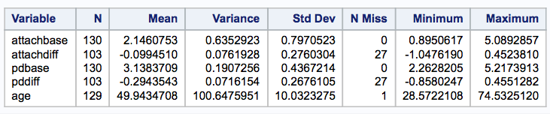

Table 2. Summary of Continuous Variables

Model selection was determined using backward elimination and partial F-tests. The treatment variables and baseline variables remained in the model and Partial F-tests were used to determine the additional value of the other covariates (age, sex, smoker, race) by comparing overall F-statistics, Partial F-statistics and their p-values, mean square error, standard error, and adjusted $R^{2}$. Using this methodology, the final model for the difference in attachment loss included treatment variables, baseline, and smoker, as a precision variable. The final model for the difference in pocket depth included only the treatment variables and baseline. Using the Partial F-tests, the coefficients of the covariates were not significantly different from 0 and did not add any value to the model. No covariates were used in the pocket depth model.

Results from the crude models differed. The

Figure 1. Attachment Loss Difference and Treatment Group

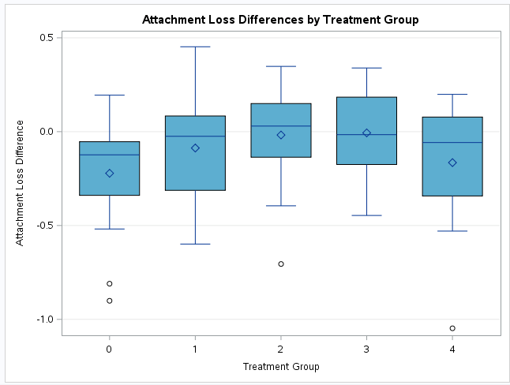

attachment loss difference model with treatment variables and no treatment as the reference was overall significant (p=0.0451). Figure 1 shows a plot of the treatment groups and attachment loss difference. In the attachment loss difference model, only the intercept (p<0.0001), low concentration (p=0.0134), and medium concentration (p=0.0101) were significant. After including baseline values, the attachment loss difference overall model became even more significant (p<0.0001). Adding in the baseline decreased the mean square error, standard error, and increased adjusted $R^{2}$. The variables medium(p=0.0232) and baseline (p<0.0001) were significantly associated with attachment loss difference, and low(p=0.0572) was marginally associated with attachment loss difference. The final model for attachment loss difference was overall significant (p<0.0001). The variables that were significantly associated with attachment loss difference in the final model were medium(p=0.0325), baseline (p<0.0001), and smoker (p=0.0525) was marginally significantly associated. There is a significant difference in attachment loss with the medium concentration treatment (p=0.0325). On average, nonsmokers receiving the medium treatment concentration, had an attachment loss difference of 0.16650cm (95%CI: 0.01416 to 0.31884) greater than nonsmokers receiving no treatment.

The crude overall model for pocket depth difference with treatment variables was not significant (p=0.0899). Figure 2 shows a plot of the treatment groups and pocket depth difference. In the crude pocket depth loss model only the intercept (p<0.001) was significant, even though the overall model was not significant. Partial F tests showed that the additional covariates would not add to the model. In the final model, with baseline, it is overall significant (p=0.0339) but only the baseline value (p=0.0461) is significantly associated with pocket loss difference, as would be expected.

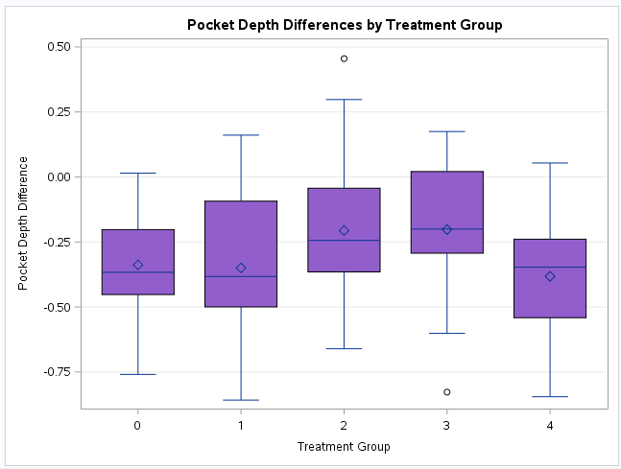

Figure 2. Pocket Depth Difference and Treatment Group

Since the medium group was significantly associated with attachment loss difference in the model, one way ANOVA was run to check least squares means and significance among groups with a Tukey-Kramer adjustment, and there was no observed significant differences between pairwise treatment groups. Table 3 shows the pairwise p-values for each group comparison.

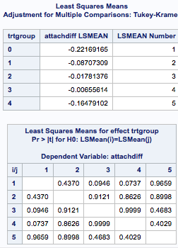

Table 3. LS Means for treatment groups

For this data, the best fitted models show an association between the medium concentration and attachment loss difference. Although the majority of parameters are not significant for the relationships between attachment loss and treatment group or for the relationship between pocket depth and treatment group, there seems to be a trend that the high concentrations have a lower difference value, meaning that their values at year one follow up are relatively lower compared to those at base. There may need to be further investigation into the high concentration gel perhaps with a larger sample.

One main limitation of this analysis is the loss to follow up. The subjects lost to follow-up amounted to about 20% of the study population, and this may have affected analysis because those outcomes are unknown. If loss to follow up is expected, a larger sample size than 130 may be a consideration in future analyses. There was also no way to confirm compliance as data on daily use was not recorded. If patients were not in compliance with the instructions to apply gel twice daily, attachment loss differences and pocket depth differences may be biased. Overall the medium concentration seems to show a statistically significant association with attachment loss, but this significance shows an increase in attachment loss at year one meaning while statistically significant the treatment did not have the intended effect. Other than the medium concentration, no major statically significant association is seen between attachment loss difference and dental gel concentration treatment group and there is no statistically significant association between pocket depth difference and dental gel concentration treatment group.

Reproducible Research

**GitHub Path:** [**bios6623-bbalkaran**](https://github.com/BIOS6623-UCD/bios6623-bbalkaran)/[Project0](https://github.com/BIOS6623-UCD/bios6623-bbalkaran/tree/master/Project0)/[Code](https://github.com/BIOS6623-UCD/bios6623-bbalkaran/tree/master/Project0/Code)/**Project_0.sas**

**Data File saved in SAS studio: /home/bridgetbalkaran0/my_courses/BIOS_6623 Advanced Data Analysis/Project_0/Project0_dental_data.csv**